Software Requirement Specification Document

For

University Elective Course Registration System

Table of Contents
- Introduction
  - Purpose
  - Intended Customers/Users
  - Product Scope
  - Outline of the document
- Overall Description
  - Product Perspective
  - Product Functions
  - User Classes
  - Design and Implementation Constraints
- Diagrams
  - UML Diagrams
  - ER Diagrams
  - DFD Diagrams
  - Assumptions and Dependencies
- External Interface Requirements/Screenshots
  - User Interfaces
  - Hardware Interfaces
  - Software Interfaces
  - Communication Interfaces
- Other Non-Functional Requirements
  - Performance Requirements
  - Safety Requirements
  - Security Requirements
  - Software Quality Attributes
  - Business Policies/Rules (if any)
- Testing
  - Block-Box Testing
  - White-Box Testing
- Conclusion
- References
- Acknowledgements

1. Introduction
1.1 Purpose
This document explains what the University Elective Course Registration System needs to do.
It is a web-based tool that helps make the process of choosing elective courses easier. Instead of doing it by hand, this system will automatically assign seats, check if students meet course requirements, and help university staff manage everything more efficiently.
1.2 Intended Customers/Users

- Students will use the system to look through course options and sign up for electives.
- Professors will be able to see which students are in their classes and get details about each enrolled student.
- University Registrars (also called admins) will manage course information, set dates for registration, and fix any problems that come up.

1.3 Product Scope
This system will be a web portal that works on regular browsers.Itwill let admins add course details like credit hours, class size, and schedules. Students can log in to see courses they are allowed to take and register for them. The system will make sure rules are followed, like not letting too many students sign up for the same course, not allowing classes that clash in time, and checking if students have met all the necessary requirements. It will not deal with paying tuition or checking if students have completed all their degree requirements. It will only focus on helping with elective course registration.
1.4 Outline of the document
This document covers all the features the system needs, how it should work, how it connects with other systems, any limits or rules it must follow, and how to test it to make sure it works well.

2. Overall Description
2.1 Product Perspective
This system replaces old paper-based or email-based registration methods.
It works as a separate part of the system but will later connect to the university's main Student Database to get student IDs and past grades.
2.2 Product Functions
User Authentication: A secure way for everyone to log in based on their role.
Course Management: Admins can add, view, edit, and remove course details.
Registration Logic: Checks in real time if there are seats left and if students meet course requirements.
Conflict Detection: Stops students from registering for courses that happen at the same time.
Roster Generation: Makes lists of registered students available for professors.
2.3 User Classes
Student: Can view course information and update their own registration.
Faculty: Can see the list of students enrolled in their courses.
Administrator: Has full access to change system settings and manage all data.
2.4 Design and Implementation Constraints
Platform: Must be a web-based application that works on Chrome, Firefox, and Edge.
Database: Needs a relational database like MySQL or PostgreSQL to ensure safe and accurate handling of student registration data at the same time.
Availability: The system must work well even when many students are trying to register at the same time, like during Registration Week.

3. Diagrams

3.1 UML Diagrams (Use Case)

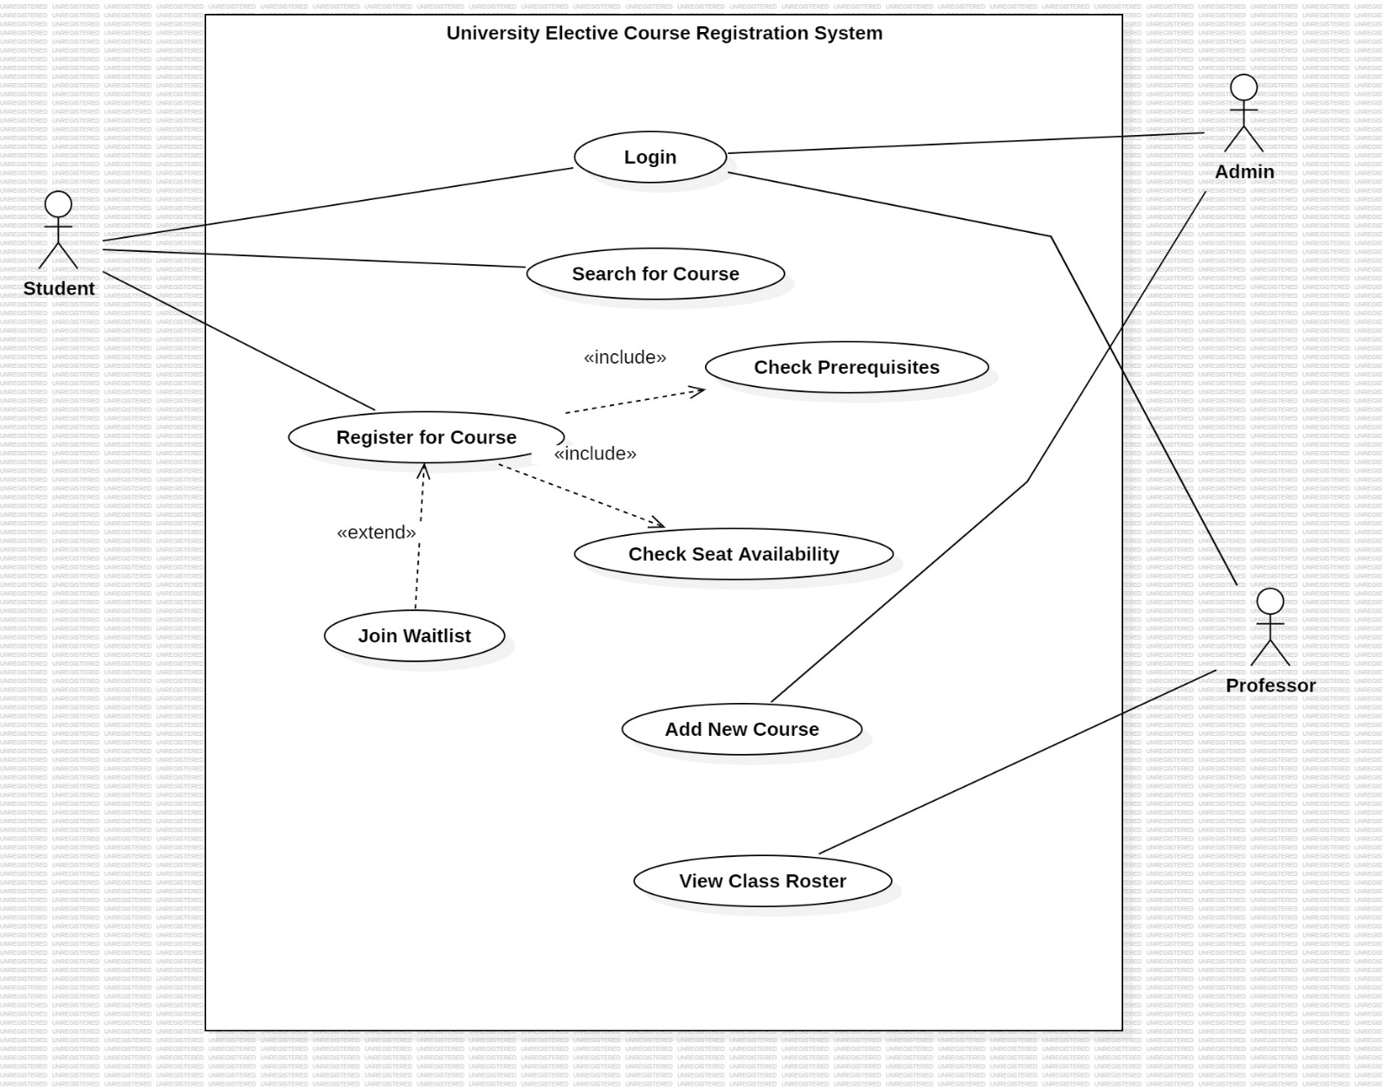

Class diagrams

5-modules

Completed modules
- Module 1-User
- Module 2-Course
- Module 3-Registration
- Module 4-Invoice
- Module 5-Payments

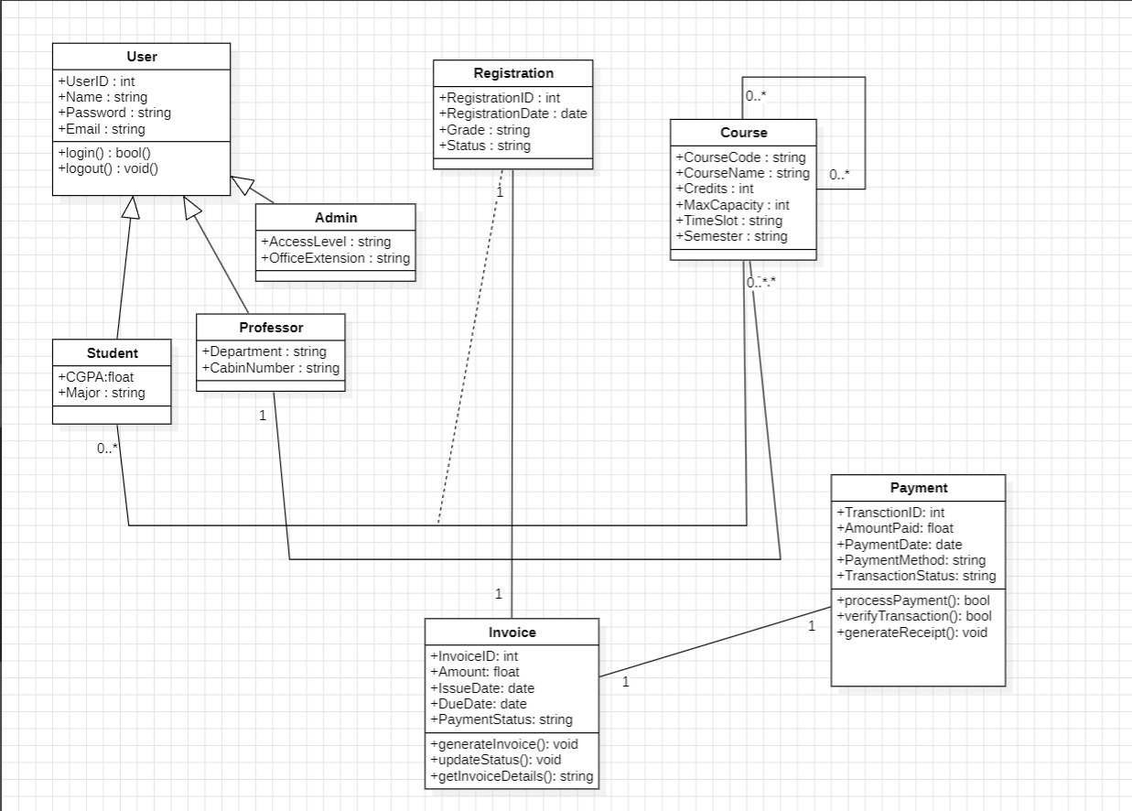

State chart diagrams

1)Course
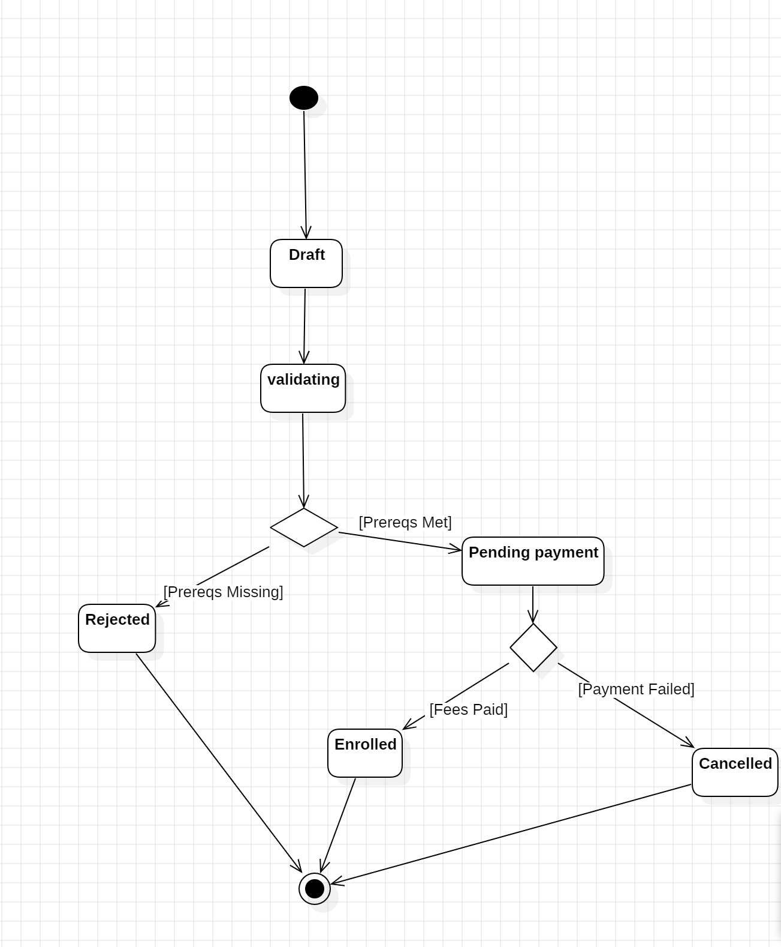
2)Registration
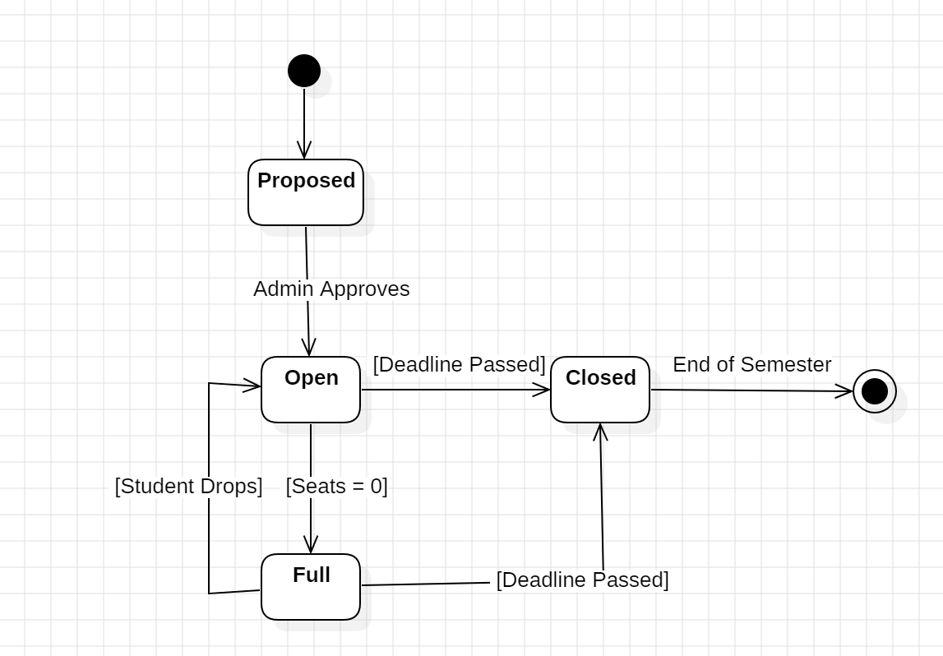

3.2) ER DIAGRAMS
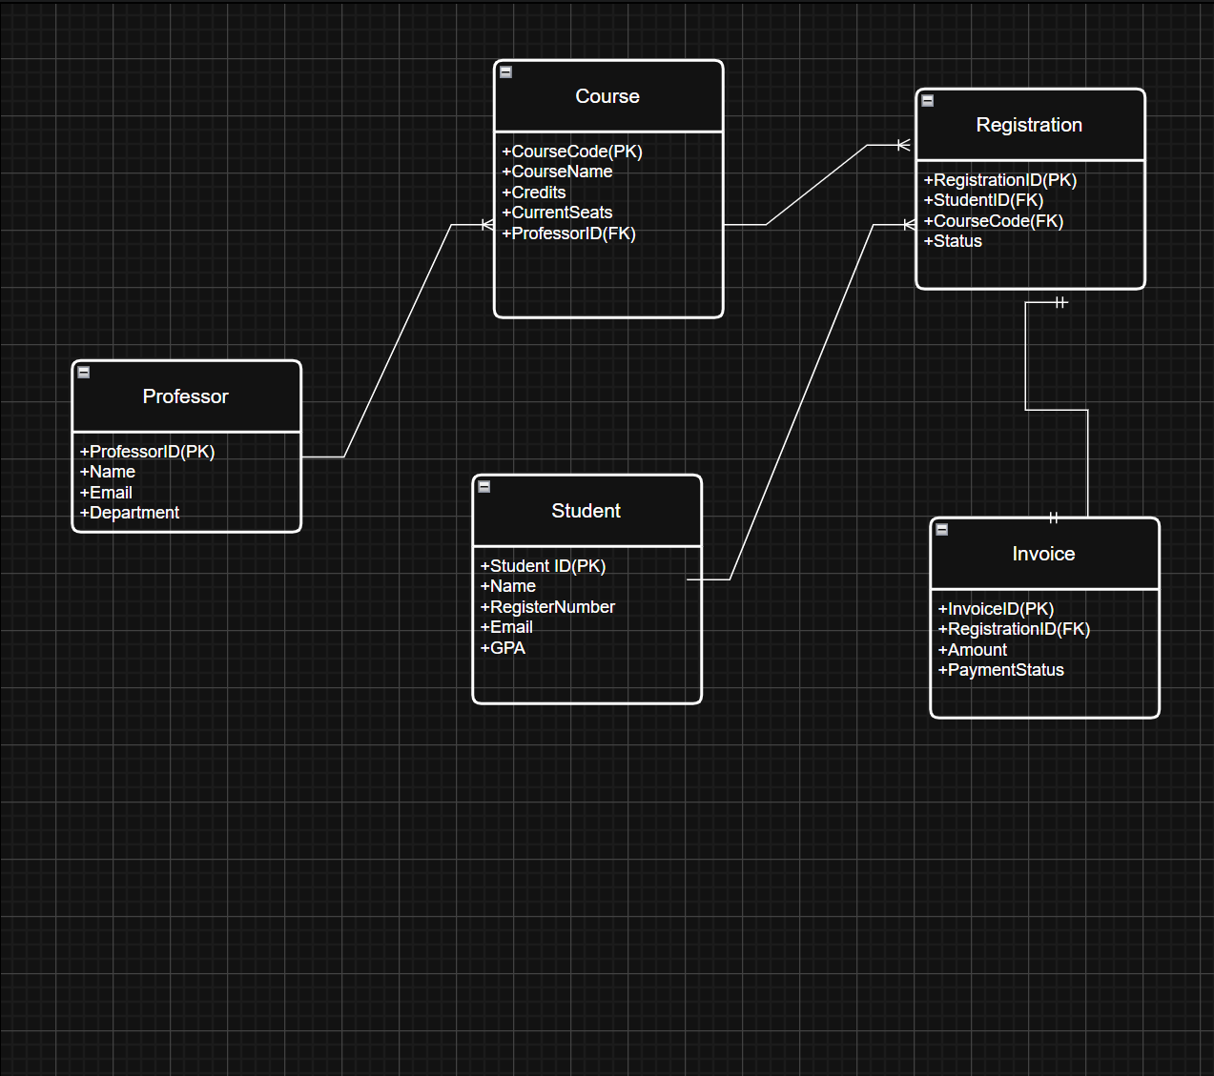

3.3 DFD DIAGRAMS
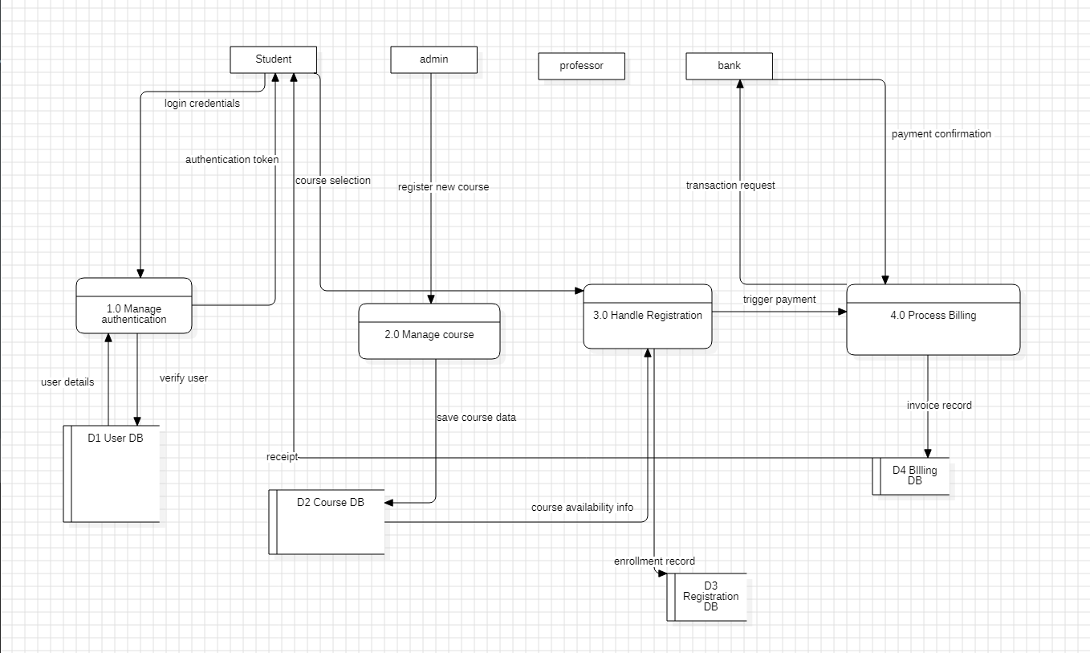

4.External Interface Requirements/Screenshots

4.1 User Interfaces
- Student Interface: Allows students to search for courses, view prerequisites, register, and pay fees.
- Professor Interface: Allows faculty to manage course details, view enrolled students, and upload grades.
- Administrator Interface: Allows admins to manage user roles, approve courses, and oversee the entire system.
4.2 Hardware Interfaces
- Server: To host the application and database.
- Client Devices: Laptops, desktops, and mobile phones used by students and faculty to access the system.
4.3 Software Interfaces
- Operating System: Windows
- Payment Gateway:UPI.
4.4 Communication Interfaces
- HTTP / HTTPS: These are the standard protocols for accessing the web application securely over the internet.
- LAN / Wi-Fi: These are the network connection types students and faculty will use to physically connect to the system.

5.Other Non-Functional Requirements

5.1 Performance Requirements
- The system shall process standard user requests, such as searching the course catalog or viewing the dashboard, within 2 seconds.
- The system must support high concurrency, capable of handling at least 5,000 simultaneous student logins during the opening hours of the registration period without crashing.
- Payment processing status updates from the Bank Gateway must be reflected in the system within 5 seconds of the transaction completion.

5.2 Safety Requirements
- The system shall perform automated, secure backups of the Registration, User, and Invoice databases every 24 hours to prevent data loss.
- In the event of a system crash or power failure during an active enrollment transaction, the system must automatically roll back to the previous stable state to ensure no partial or corrupt registrations are saved.
- Error messages displayed to the user must be clear and non-technical, safely hiding backend server details or database queries to prevent exploitation.

5.3 Security Requirements
- All network communication between the client browser and the application server shall be encrypted using standard HTTPS/TLS protocols.
- The system shall enforce strictly defined Role-Based Access Control (RBAC), ensuring students can only view and modify their own registrations, while only administrators and professors can modify course details or capacities.
- User passwords must never be stored in plain text; they must be hashed and salted in the database.
- The system shall automatically lock a user account for 15 minutes after five consecutive failed login attempts to prevent brute-force attacks.

5.4 Software Quality Attributes
- Availability: The system must guarantee 99.9% uptime, especially during the critical two-week elective registration window.
- Usability: The web interface shall be highly intuitive and responsive, allowing a student to successfully navigate the platform, search for a course, and complete enrollment without requiring formal training or manuals.
- Maintainability: The backend codebase must remain modular (separated into distinct User, Course, Registration, and Billing components) so future updates to one module do not break the others.
- Scalability: The architecture must be designed to easily scale server resources up during peak registration weeks and scale down during the middle of the semester to optimize hosting costs.

5.5 Business Policies/Rules
- Credit Limit Rule: The system shall strictly block any student from registering for courses that would push their active schedule beyond the maximum limit of 21 credits per semester.
- Prerequisite Enforcement: A student cannot register for an advanced course unless the system verifies they have successfully completed the linked prerequisite course.
- Waitlist Allocation: When a course reaches maximum capacity, subsequent students are added to a waitlist. If a registered student drops the course, the open seat must be offered automatically to the first student on the waitlist (First-In, First-Out).
- Payment Deadline: A registration remains in a 'Pending Payment' state until the invoice is cleared. If payment is not completed within 48 hours of course selection, the registration is automatically dropped, and the seat is released

6)TESTING
Course registration function is tested
6.1) white box testing
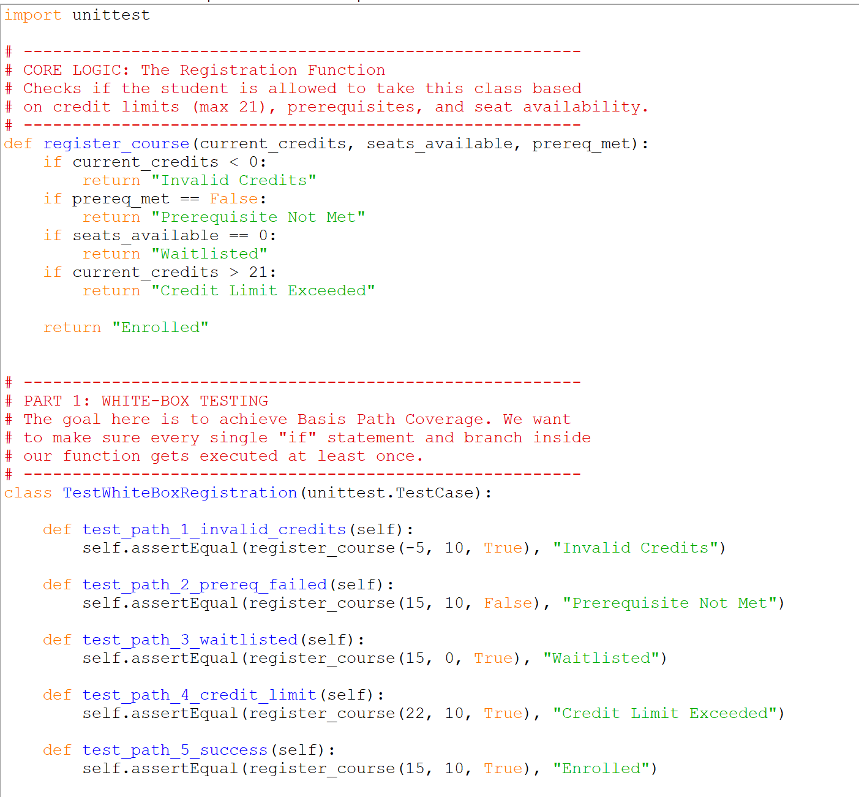

6.2) black box testing
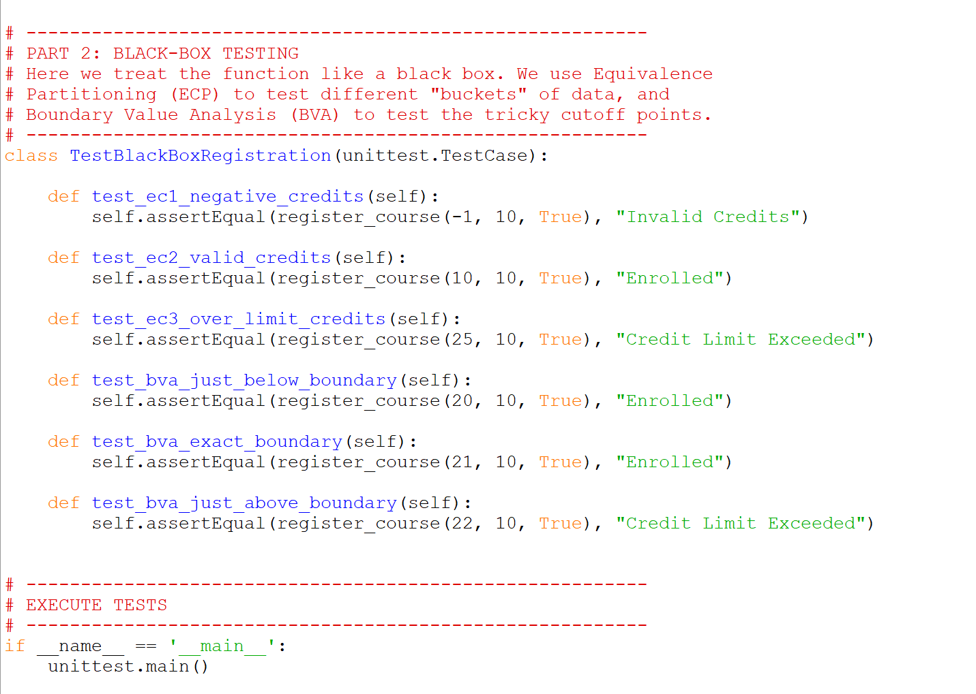

Control Flow Graph
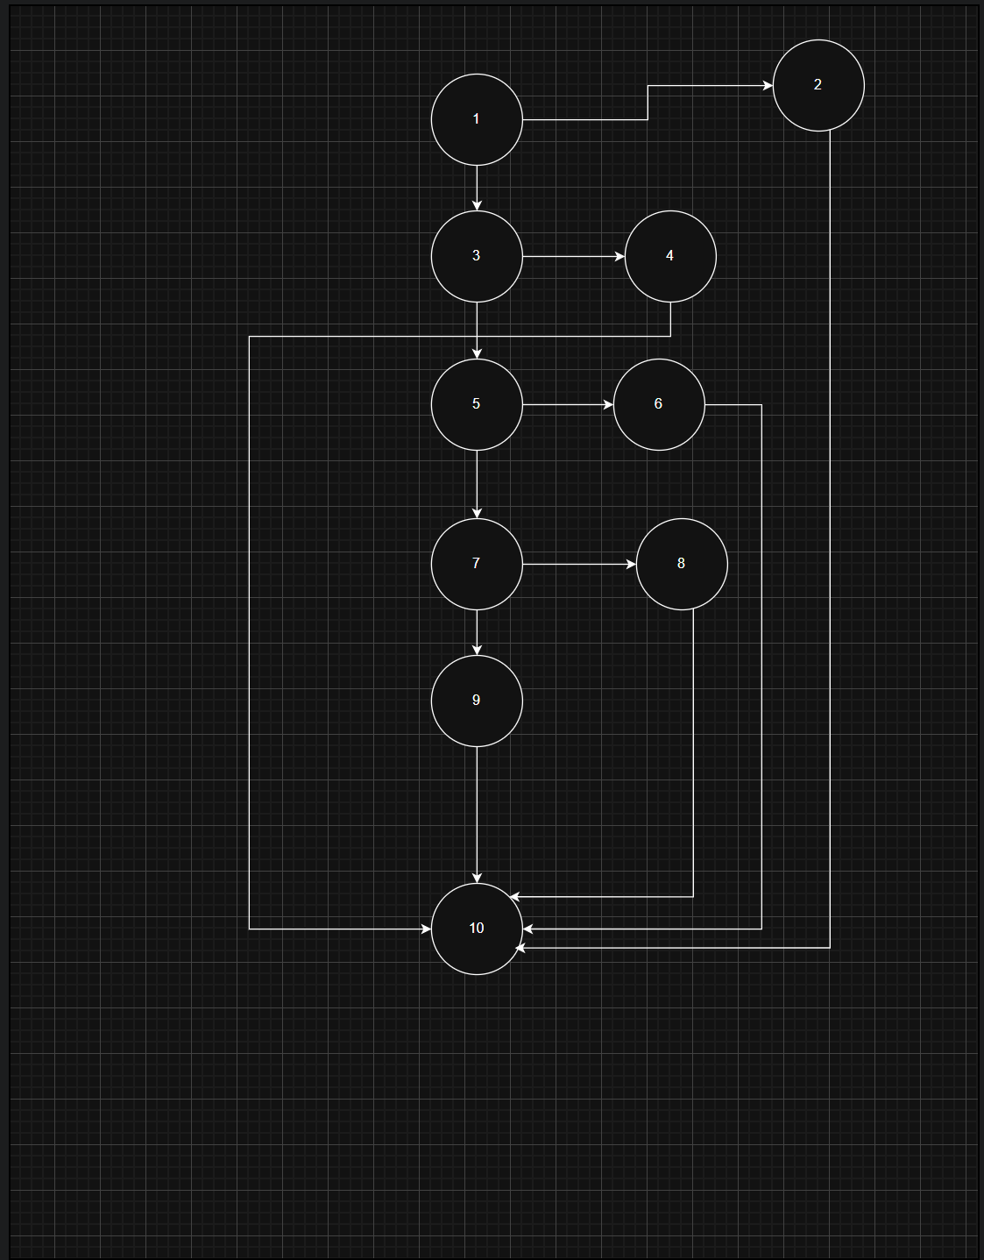

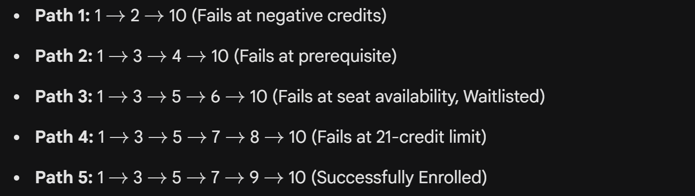

Testing Summary and Conclusion
In conclusion, the testing phase for the Course Registration module successfully validated both the internal logic and the external functional requirements of the system. Using White-Box testing techniques, specifically Basis Path Testing, a Control Flow Graph was constructed to measure the complexity of the software program. This revealed a Cyclomatic Complexity of 5, leading to the identification of 5 independent program paths. Test cases were successfully executed to cover each of these paths, ensuring comprehensive coverage of all internal statements and branches.

To complement this structural analysis, Black-Box testing was performed to evaluate the functionality of the system as a whole. By applying Equivalence Class Partitioning (ECP) to divide inputs into logical groups and Boundary Value Analysis (BVA) to test the extreme ends of our input ranges, the system was rigorously evaluated against its business rules—most notably the 21-credit maximum limit. All defined unit tests passed successfully without error. Ultimately, this dual-perspective testing strategy confirms that the registration engine reliably processes valid enrollments, correctly routes students to waitlists, and effectively blocks prerequisite or credit violations.

7)Conclusion
The development of the University Elective Course Registration System represents a significant step forward in modernizing and streamlining academic administration. By transitioning from fragmented processes to a centralized, automated platform, this software ensures a seamless and efficient enrollment experience for students, professors, and administrative staff.

Throughout the development lifecycle, strict adherence to core software engineering principles was maintained. The system's architecture was meticulously planned using comprehensive UML and system modeling, including Data Flow, Entity-Relationship, Component, and Deployment diagrams. This structured approach ensured that the four primary modules—User Management, Course Catalog, Registration Engine, and Billing System—were seamlessly integrated and highly cohesive.

A major success of this project lies in its robust enforcement of academic business rules. The core logic effectively handles complex constraints, such as the 21-credit maximum limit, strict prerequisite tracking, and automated waitlist allocation. The reliability of these functions was mathematically and practically proven through rigorous software testing. By applying White-Box testing (Basis Path Testing with a Cyclomatic Complexity of 5) alongside Black-Box testing (Equivalence Class Partitioning and Boundary Value Analysis), the system was validated to handle extreme inputs and edge cases without failure.

Furthermore, the system successfully meets all critical non-functional requirements. It is designed to be highly secure through encrypted communication and Role-Based Access Control (RBAC), scalable enough to handle the high concurrency of peak registration weeks, and reliable enough to prevent data loss during transaction interruptions.

Ultimately, this project delivers a scalable, user-friendly, and highly maintainable software solution. It completely fulfills the defined functional and non-functional requirements, drastically reduces administrative overhead, and provides a strong, modern technological foundation for the university's academic operations.

DESIGN ARCHITECTURE

1)Component Diagram
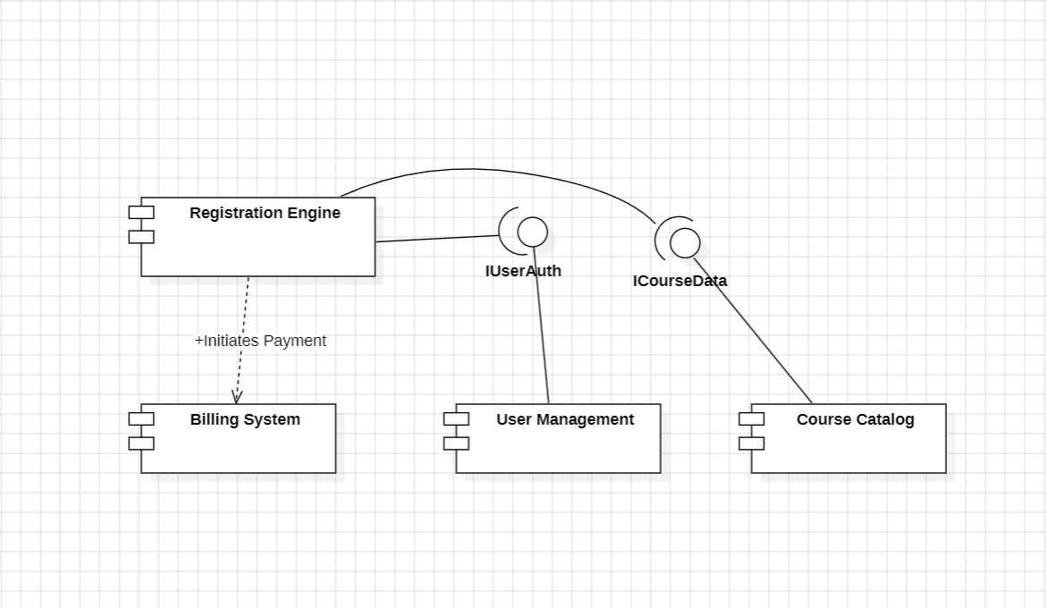

2)Deployment Diagram
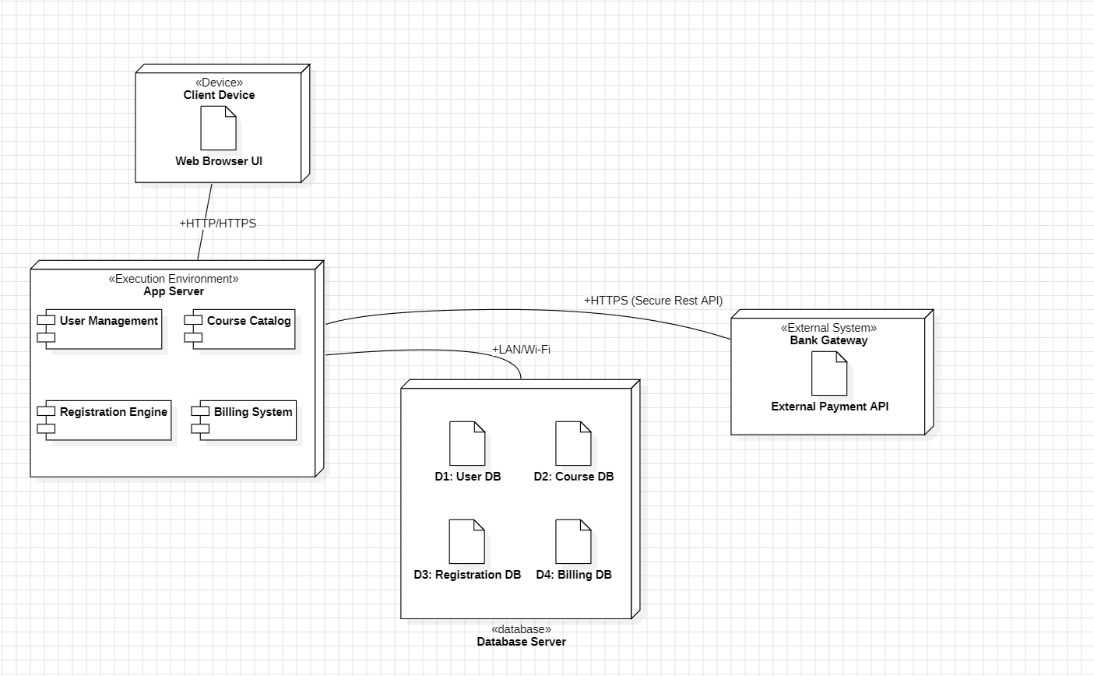

Specific Metrics for the Requirements Model

1. Function-Based Metrics (System Size & Scale) Derived from the project's Information Domain and Function Point Analysis (FPA):
- Total Function Points (FP): 91 FP
- Estimated Development Effort: ~910 person-hours (assuming 10 hours per FP)
- External Inputs (EIs): 4 (Logins, Course Creation, Registration Submission, Payment Submission)
- External Outputs (EOs): 2 (Automated Invoices, Student Dashboards)
- External Inquiries (EQs): 3 (Course Catalog Search, Waitlist Queries, Schedule Checks)
- Internal Logical Files (ILFs): 4 (User DB, Course DB, Registration DB, Billing DB)
- External Interface Files (EIFs): 1 (External Bank Payment Gateway)

2. Functional Scope Metrics (Analysis Model) Quantifying the architectural breakdown of the system prior to design:
- Total System Modules: 5 (User Management, Course Catalog, Registration Engine, Invoice Generation, Payment Processing)
- Total Distinct User Roles: 3 (Student, Professor, Administrator)
- Total External Dependencies: 1 (External Bank API for transaction verification)

3. Specification Quality Metrics (Business Rule Constraints) The quantifiable strict constraints that the design and code must perfectly execute:
- Maximum Credit Threshold: 21 credits per student per semester.
- Payment Expiration Window: 48 hours from course selection to payment completion before automatic drop.
- Waitlist Allocation Logic: 1 strict First-In, First-Out (FIFO) queue per fully booked course.
- Role-Based Access Control (RBAC) Levels: 3 distinct access tiers governing database read/write permissions.

Function Point Analysis (FPA) for the Course Registration System

Step 1: Calculate the Count Total (Unadjusted Function Points - UFP)
The functionality of the system is categorized into Information Domain Values. An "Average" weighting factor is assigned to each item according to standard FPA practices.
- External Inputs (EIs): Data coming in from the user to update internal files.
  - Student/Professor login credentials
  - Admin submitting a new course to the catalog
  - Student submitting a course registration
  - Student submitting payment details
Count: 4
- External Outputs (EOs): Information derived from the application and presented to the user.
  - Generated Invoice/Receipt
  - Registration Status Dashboard
Count: 2
- External Inquiries (EQs): Online inputs that trigger an immediate search and response.
  - Searching the course catalog for open seats
  - Admin viewing the waitlist
  - Student checking their current enrolled schedule
Count: 3
- Internal Logical Files (ILFs): Logical groupings of database data maintained within the system.
  - User Database (Students/Professors)
  - Course Database
  - Registration Database
  - Invoice/Billing Database
Count: 4
- External Interface Files (EIFs): Data residing outside the application but used by it.
  - External Bank Gateway (for payment verification)
Count: 1
UFP Calculation Table:
Information Domain Value | Count | Weighting Factor (Average) | Total
External Inputs (EIs) | 4 | x 4 | 16
External Outputs (EOs) | 2 | x 5 | 10
External Inquiries (EQs) | 3 | x 4 | 12
Internal Logical Files (ILFs) | 4 | x 10 | 40
External Interface Files (EIFs) | 1 | x 7 | 7
Count Total (UFP) |  |  | 85
Step 2: Calculate the Complexity Adjustment Factor (CAF)
The CAF adjusts the functional size based on 14 general system characteristics (e.g., security needs, performance requirements, data communications). Each factor is rated on a scale of 0 (No Influence) to 5 (Essential).
Assuming an "Average" influence for all 14 factors for this university system, the rating is 3.
- Sum of value adjustment factors = 14 x 3 = 42
Using the empirical formula:
CAF = 0.65 + (0.01 x 42)
CAF = 0.65 + 0.42
CAF = 1.07
Step 3: Calculate Final Function Points (FP)
The final step is to multiply the Count Total (UFP) by the Complexity Adjustment Factor (CAF).
FP = 85 x 1.07
FP = 90.95

Analysis Conclusion:
The system has a functional size of approximately 91 Function Points. This metric provides a concrete baseline for forecasting the effort and cost required to build the software. For instance, if the development team historically averages 10 hours of work per Function Point, the estimated development time for this project would be roughly 910 hours.

COCOMO MODEL

Cost and Effort Estimation (COCOMO Model)
To estimate the effort, time, and staff required for the University Elective Course Registration System, the Constructive Cost Model (COCOMO) is applied.

1. Project Categorization and Sizing
- Software Size (KLOC): Based on the prior Function Point Analysis of 91 FP, and using a standard conversion rate for object-oriented languages (approx. 50 lines of code per FP), the estimated size of the system is 5 KLOC (5,000 Lines of Code).
- Development Mode: The project is classified as an "Organic" project. This is because it is a relatively small-sized project being developed by a small team in a familiar, in-house environment.

2. Basic COCOMO EstimationThe Basic COCOMO model provides a rough calculation of software costs using only the estimated lines of code.
- Formulas Used:
  - Effort (E) = A * (KLOC)^B Person-Months
  - Time (T) = C * (Effort)^D Months
- Constants for Organic Mode: A = 2.4, B = 1.05, C = 2.5, D = 0.38
Calculations (Basic):
- Effort: 2.4 * (5)^1.05 = 13.02 Person-Months
- Development Time: 2.5 * (13.02)^0.38 = 6.53 Months
- Staff Required: Effort / Time (13.02 / 6.53) = approx. 2 Developers

3. Intermediate COCOMO EstimationThe Intermediate model refines the basic estimate by factoring in 15 subjectively assessed "cost drivers" (such as reliability, complexity, and personnel capability). These drivers are multiplied together to create an Effort Adjustment Factor (EAF).
- Formulas Used:
  - Effort (E) = (A * (KLOC)^B) * EAF
  - Time (T) = C * (Effort)^D
- Constants for Intermediate Organic Mode: A = 3.2, B = 1.05, C = 2.5, D = 0.38
- Cost Drivers (EAF): For this academic project, we assume all 15 cost drivers are "Nominal" (rating of 1.00), resulting in an EAF of 1.0.
Calculations (Intermediate):
- Effort: 3.2 * (5)^1.05 * 1.0 = 17.36 Person-Months
- Development Time: 2.5 * (17.36)^0.38 = 7.29 Months
- Staff Required: Effort / Time (17.36 / 7.29) = 2.38 (Rounded to 3 Developers)

Estimation Conclusion
Based on the Intermediate COCOMO model, which accounts for the specific nature of software development cost drivers, building the Elective Course Registration System will require approximately 17 Person-Months of effort. To complete the project within a reasonable timeframe of roughly 7.3 months, a dedicated team of 3 developers is recommended.

